**AIM**

Write a C program to search a number using Linear Search method

**ALGORITHM:**

• Start the program.

• Read the size of the array n.

• Input the n elements into the array.

• Read the key element to be searched.

• Set a flag = -1.

• Repeat for each index i from 0 to n-1:

* If arr[i] == key, set flag = i and break.

• If flag ≠ -1, print that the element is found at position flag.

• Otherwise, print that the element is not found.

• End the program.

**CODE:**

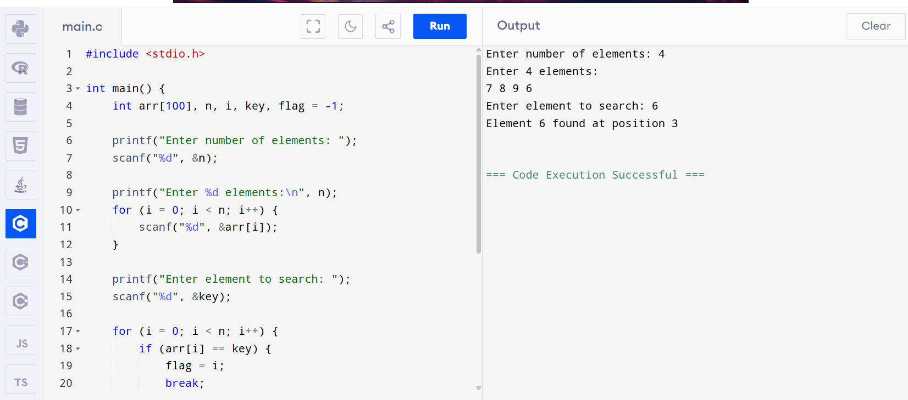

Output

Enter number of elements: 4

Enter 4 elements:

7 8 9 6

Enter element to search: 6

Element 6 found at position 3